**Exemplar: Adding data to a worksheet**

**Overview**

In the exercise *Adding data to a worksheet,* you had to add data to a Microsoft Excel workbook. You then formatted the information so that it was easy for an audience to read and understand.

**Excel User Interface**

In this course, we use the Microsoft 365 Desktop version of Excel. Microsoft 365 releases updates on a monthly basis, incorporating new features. You might experience changes in the Excel Desktop User Interface (UI) that have taken place after the development of this training content. As a result, the screenshots in the videos, readings, or exercises might not align exactly with how you experience the UI. However, please note that these changes do not impact the functionalities of the UI. Hence, you will still be able to perform all the steps shown in that video, reading, or exercise.

**Adding data to a worksheet**

This reading is a step-by-step guide for this process and includes screenshots that you can compare against your own copy. It also includes video and reading references to where the topics are covered.

**Step 1: Download and open the required files**

Download and open the Excel file named *Sample.xlsx* and the *Exchange Rates.pdf*file. The Excel file contains two worksheets, the first of which is named **Sheet1**. There is information in this worksheet that needs editing.

**Step 2: Verify and correct the existing information in the sheet**

1. You need to remove the State abbreviation column as it is no longer needed. Select the letter **B** that identifies the column, then right-click and select **Delete columns** from the shortcut menu. Once the required column is removed, the worksheet should resemble the screenshot.

**Tip:** Deleting columns is covered in the reading *Working with Rows and columns.*

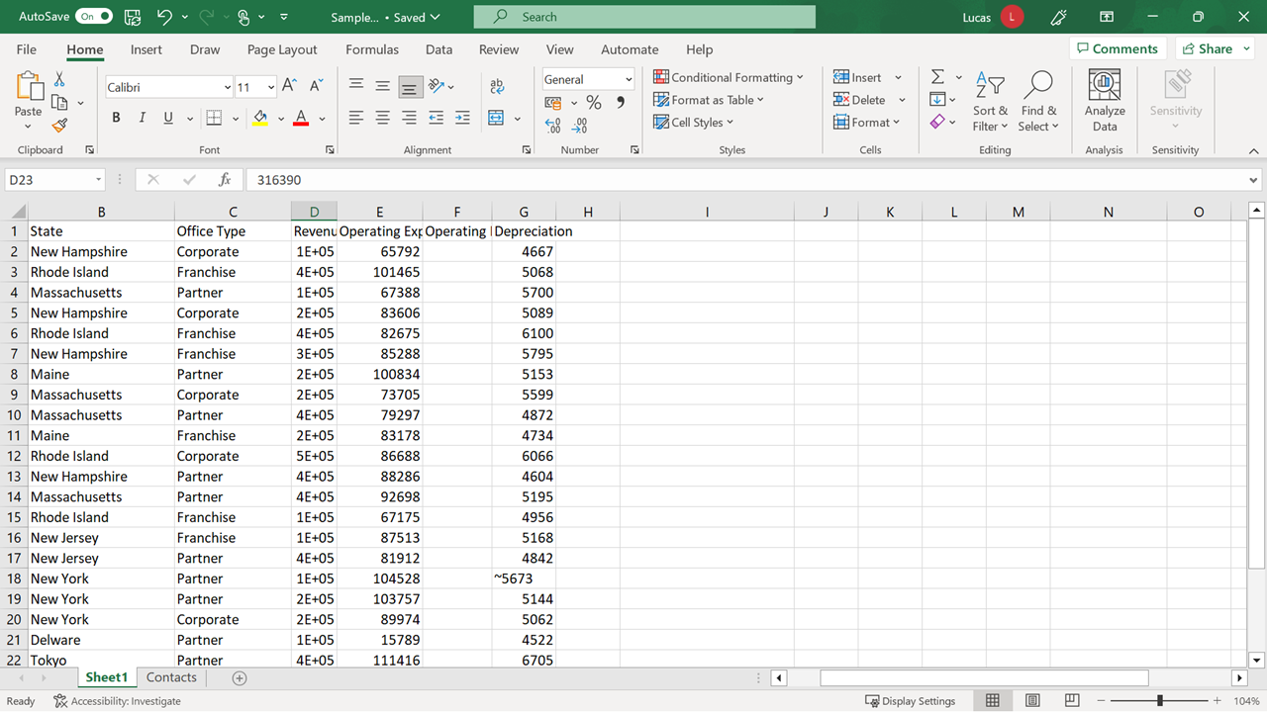

1. The entries in column **D** are not displayed in full because the column is too narrow. You need to widen the column to display the information in full. Position the mouse pointer on the vertical line between the letters **D** and **E** that identify the columns, then double-click to resize the column automatically.

**Tip:** Resizing columns is covered in the reading *Working with Rows and Columns.*

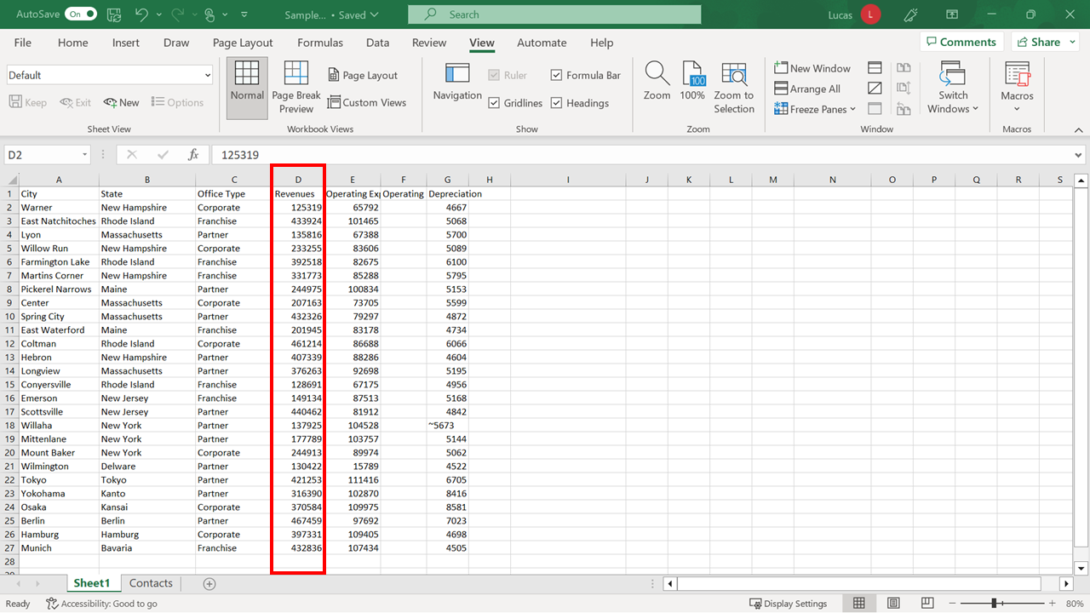

1. There is a typing error in **G18**. Excel treats it as text because there is a text character in front of the number. Edit the cell to remove the non-numeric (text) character. Double-click on the **cell** to enter edit mode. Then move the cursor to the right of the character and press **backspace**. Press **Enter** to confirm the amendment and correctly realign the entry.

**Tip:** Controlling the format of cell entries is covered in the video *Entering and formatting data.*

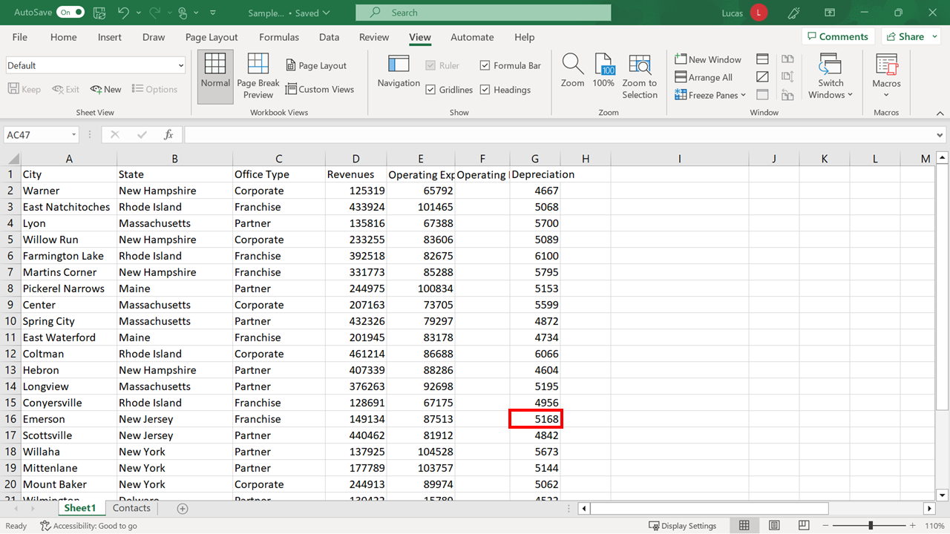

1. You need to add a country column to provide clarity around the worksheet’s international financial data. Select the letter **C** that identifies the **Office Type** column (column **C**) to select the column. Then right-click and choose **Insert Columns** from the shortcut menu. A new blank column appears to the left of the column you highlighted.

**Tip:** Inserting and deleting columns is covered in the reading *Working with Rows and Columns.*

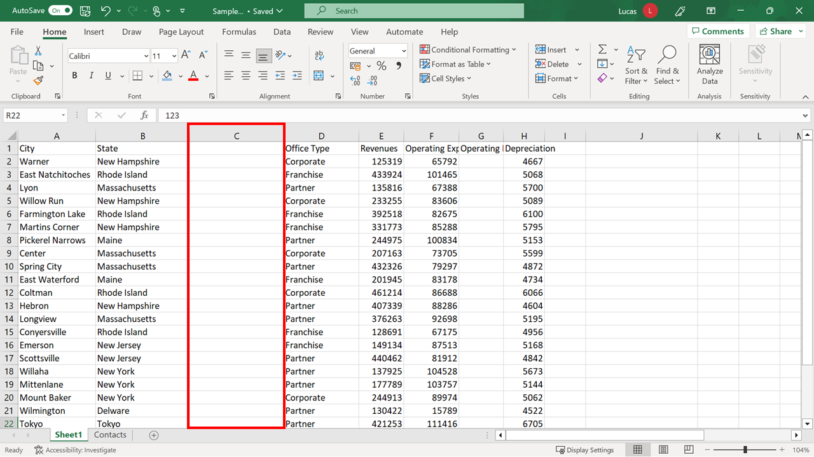

1. Type the heading **Country** in **C1** and then **United States** in **C2**. Move the cursor back to **C2**, then hover the mouse pointer over the bottom right-hand corner until it becomes the narrow black cross. Hold down the mouse button and drag it down as far as row **21** to copy the entry quickly into the appropriate cells. Add **Japan** to **C22** and use a similar **Autofill** technique to complete the country entries in rows **23** and **24**. Add **Germany** to **C25** and use a similar **Autofill** technique to complete the country entries in rows **26** and **27**.

**Tip:** This method is covered in the video *Entering and formatting Data.*

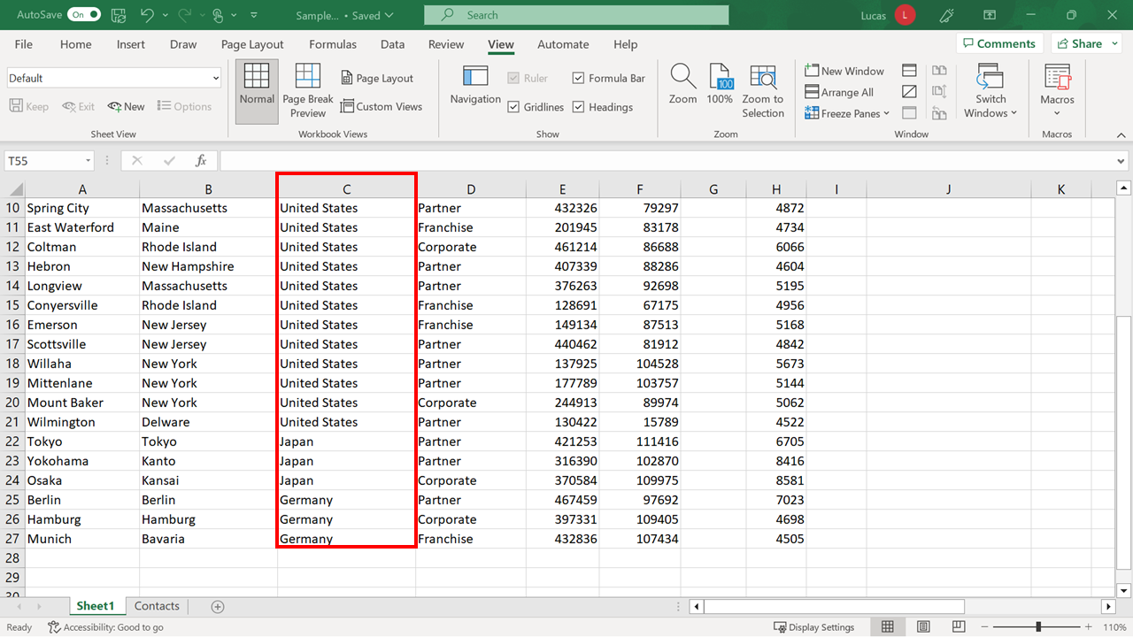

1. Next, you need to add the country names as headings above both sets of information to create a clearer distinction between the three countries. First, select row number **22** on the left-hand side. Then right-click and choose **Insert Rows** from the shortcut menu. Select row **26** and repeat the insert rows operation. Then type **Japan** in **A22** and **Germany** in **A26**.

**Tip:** This is covered in the reading *Working with Rows and Columns.*

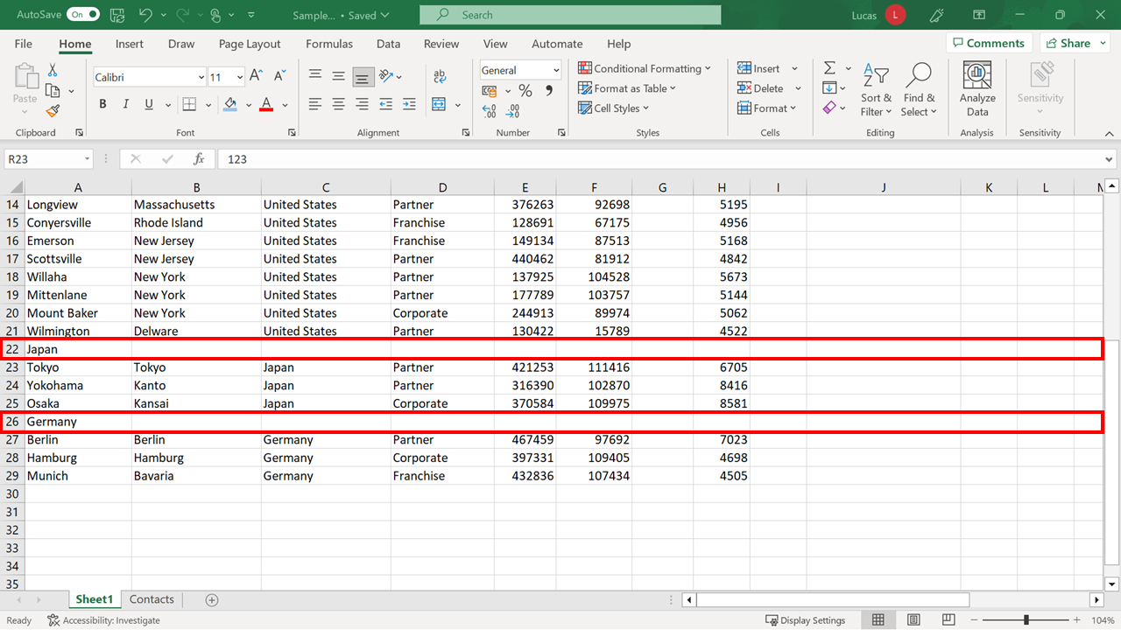

**Step 3: Format the data**

Sheet1 now contains all the required information. In this step, the focus shifts to formatting the data so that key details stand out.

1. First, you need to apply font and alignment changes to the headings, or titles. Highlight the block of cells **A1** to **H1**. On the **Home** tab, choose the **Font** group, then choose **Font size 14** and a different **Background** **color**. Without canceling the highlight, center the headings using the **Center** choice in the **Alignment** group.

**Tip:** Changing **Font** and **Alignment** are covered in the video *Entering and formatting data.*

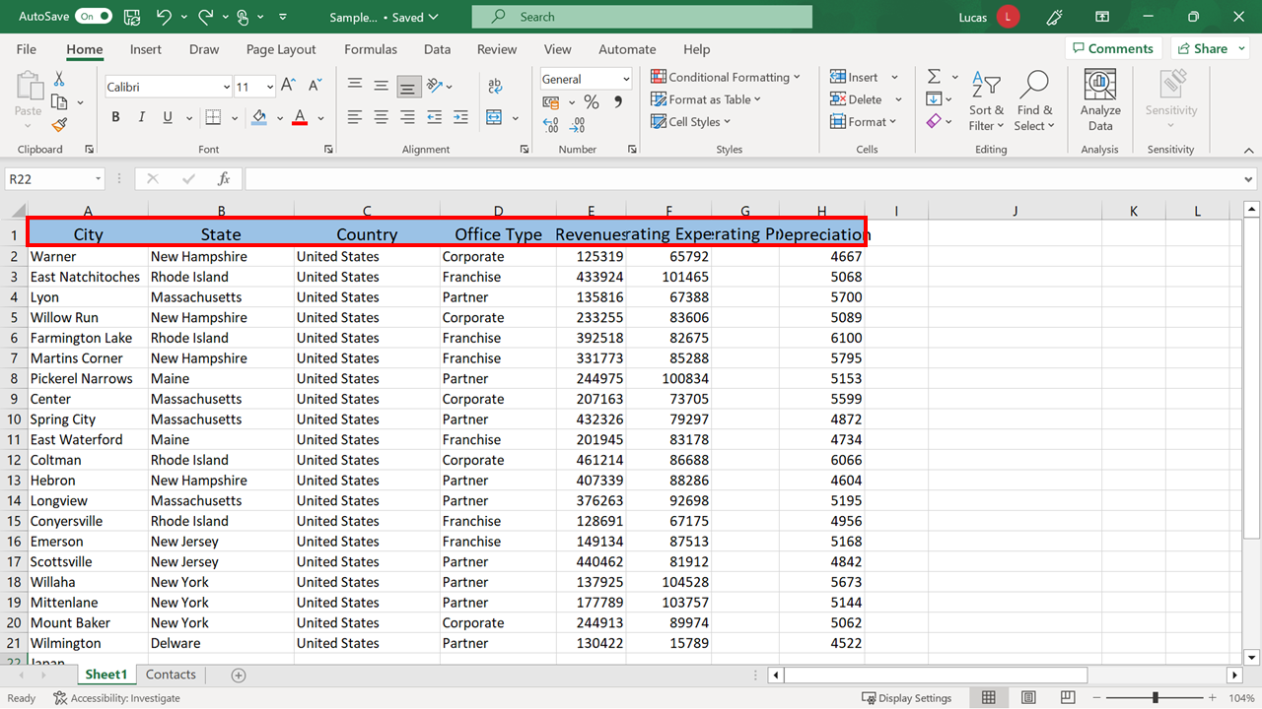

1. Increasing the size of the text has an impact on the visibility of the titles. The text is bigger, so you must widen columns **E** and **H**, which contain single-word headings. Double-click on the **vertical separator** between **E** and **F** to automatically resize column **E**. Then perform a similar adjustment on column **H**. Your worksheet should look similar to the screenshot below.

**Tip:** Resizing columns is in the reading *Working with Rows and Columns.*

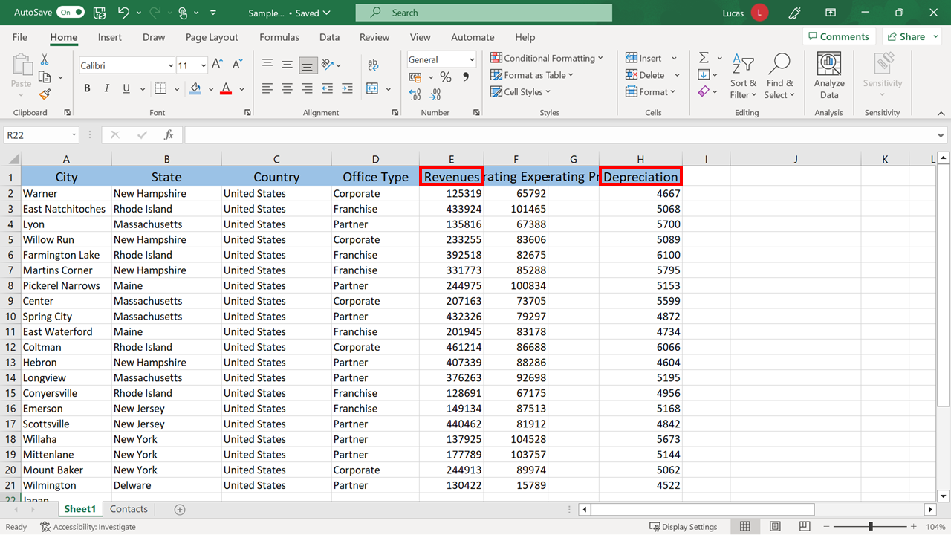

1. The headings in columns **F** and **G** are multi-word headings. Format the headings with the **Wrap Text** feature. This feature stacks the words in the cell. Column **G** requires further manual adjustment to ensure that the word “operating” is not split across two lines. Select **F1** and **G1 o**n the **Home** tab and choose **Wrap Text**. Column **G** still needs to be a little wider. So, hover the mouse pointer over the dividing line between **G** and **H**, hold down the mouse button, and drag it slightly to the right.

**Tip:** **Cell alignment** is covered in the video *Entering and formatting data* and resizing columns in the reading *Working with Rows and Columns.*

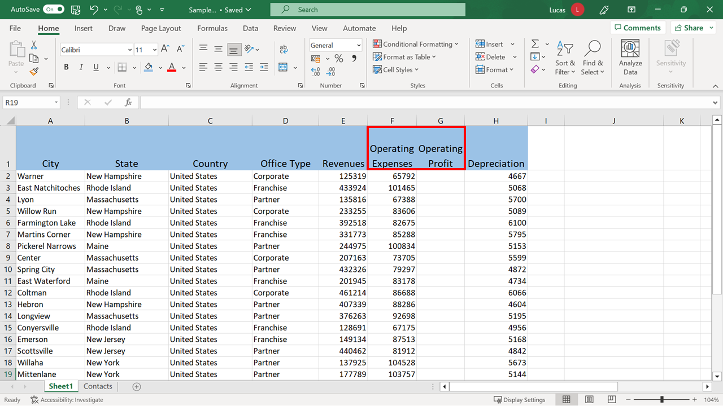

1. The country names in **A22** and **A26** also function as titles. Format them in the same way as the heading in **A1**. Use the Excel shortcut, the **Format Painter**, to achieve this.

**Tip:** Using the **Format Painter** feature is covered in the video *Entering and formatting data.*

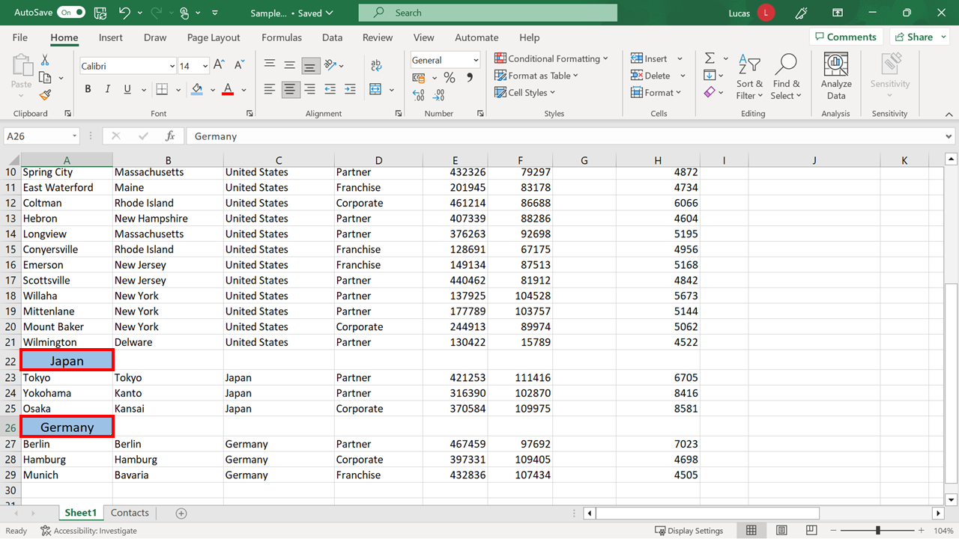

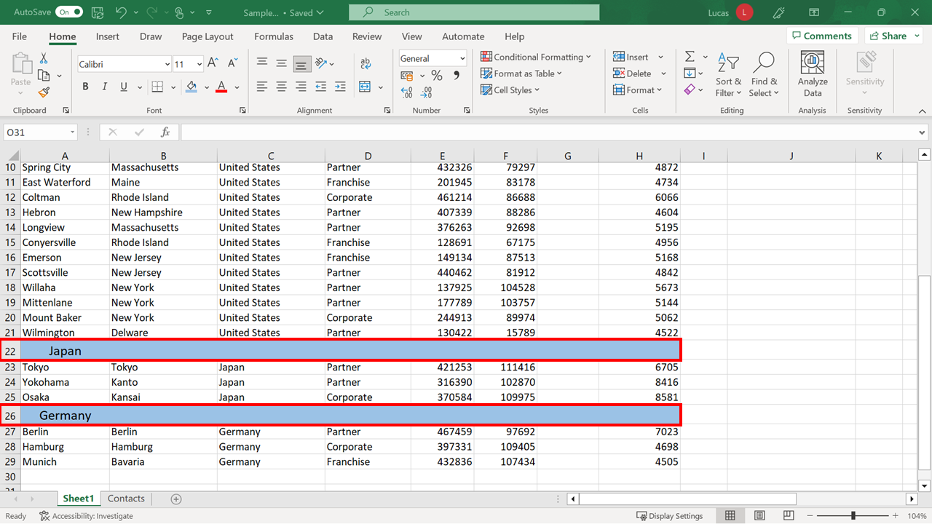

1. The figures in cells **E2** to **H21** are dollar amounts. Add a **Dollar currency** format to those cells. This automatically adds the dollar symbol, a comma, and two decimal places. Some of the entries are lengthened. Therefore, you need to widen column **F**. When these actions have been completed your worksheet should resemble the screenshot.

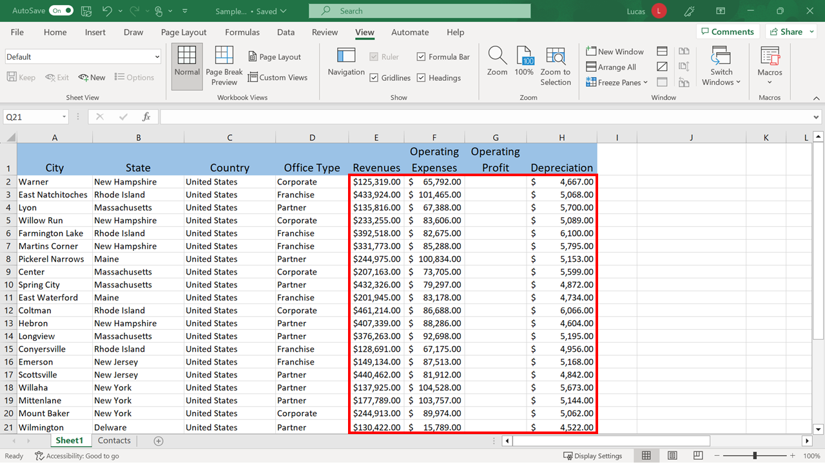

1. Similarly, the amounts in cells **E27** to **H29** must be formatted as Euro. To do this, choose the **Euro currency** format from the **Currency** drop-down.

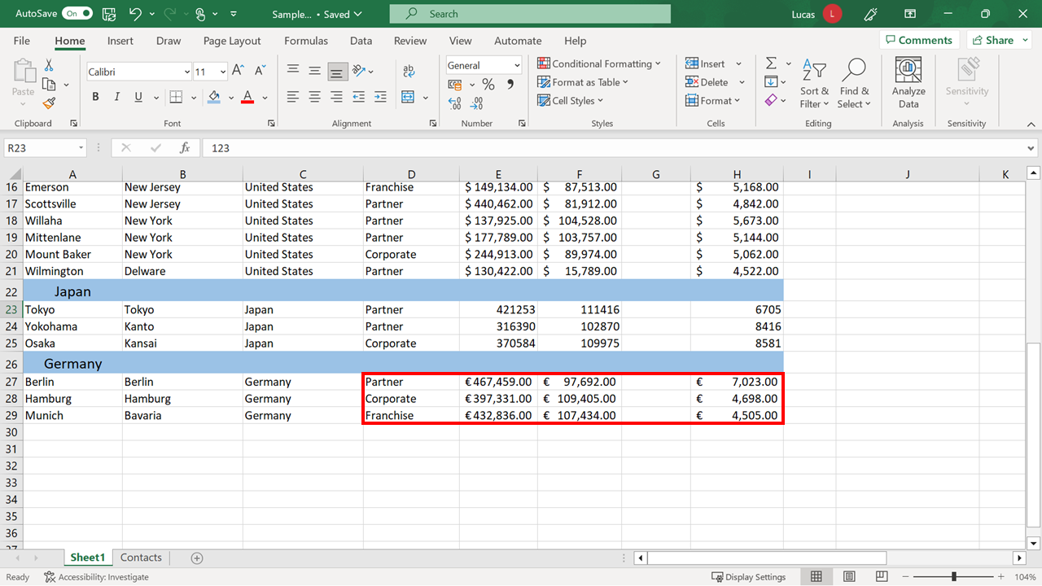

1. You need to format the figures in **E23** to **H25** as Japanese Yen. However, the Japanese Yen option is not available on the shortcut list. Select the **More Accounting Formats** choice at the bottom. Select the **Currency** category from the left of the number format dialog. Choose **¥ Japanese** (also known as Japanese Yen) from the **Symbol** drop-down on the right.

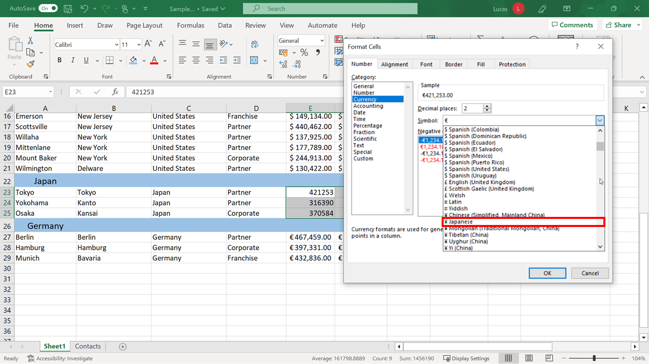

**Step 4: Add new information to the workbook**

Add the information in the PDF, **Exchange Rate.pdf** to the workbook.

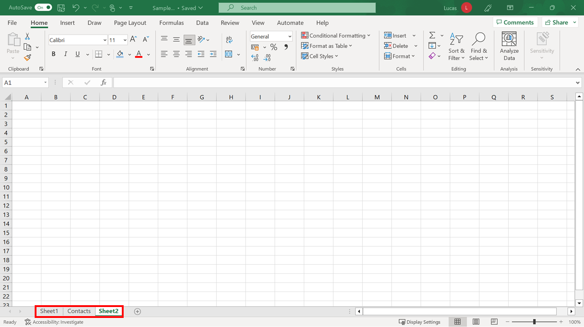

1. The sheet that you have just formatted contains Japanese and Euro currency amounts. The exchange rate information in the PDF is relevant to the company’s latest financial presentation. Add a new worksheet to the workbook to hold this data. Create a new worksheet by clicking the **+** symbol in the worksheet **tab** area.

**Tip:** Inserting new worksheets is covered in the reading *Working with worksheets.*

1. Type the exchange rate information from the PDF file into this worksheet. Type the heading **USD Amount** in cell **A1** of the new worksheet. In cell **B1**, type the heading **Currency**.

In cell **C1** type the heading **Rate**. Format these headings to match the headings in **Sheet1** to provide continuity between both sheets.

In **A2**, type the number **1***,* and in **B2** type **Yen**. In **A3**, type the number **1***,* and in **B3** type **Euro**. Then, in **C2** and **C3**, add the exchange rate figures from the PDF.

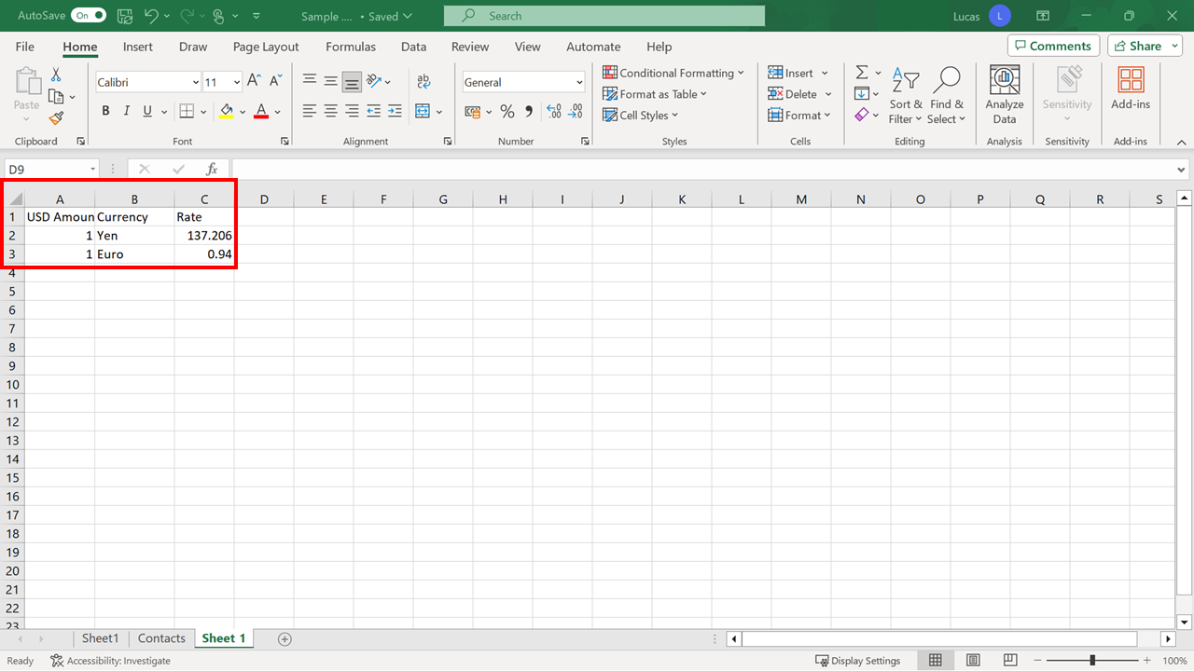

1. Format the headings in this sheet to have the same formatting as those in **Sheet1.** To do this, make similar changes, as you did in Step 3, to the look of the headings in **A1, B1 and C1.**

**Tip:** Formatting headings is covered in the video *Entering and formatting data.* You can use the **Format Painter** feature to copy formats from one sheet to another.

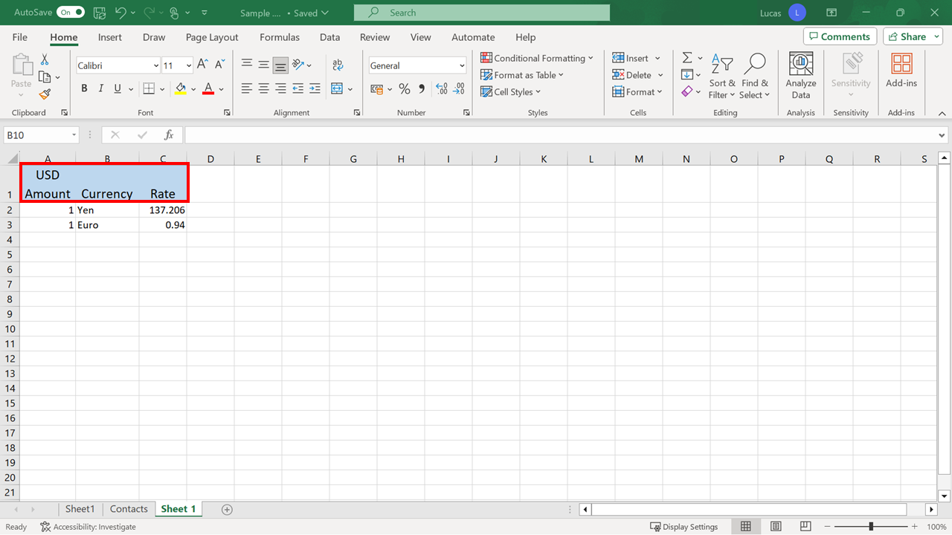

**Step 5: Manage the worksheets**

The final steps in preparing this Excel workbook for the management meeting involve renaming, moving, and hiding sheets.

1. Rename **Sheet1** to **Sample Figures** and name the new sheet you added as **Exchange Rates.** Right-click the relevant sheet **tab**, type the new name, and select **OK**.

**Tip:** Renaming worksheets is covered in the reading *Working with worksheets*.

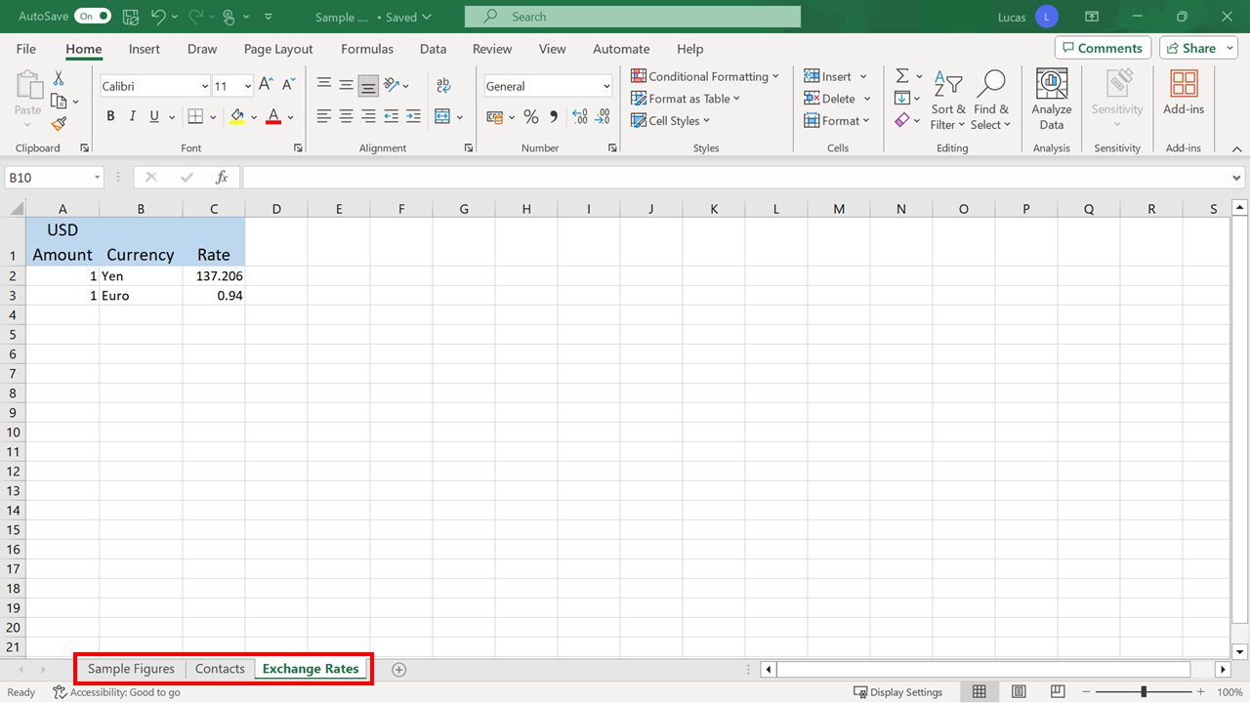

1. Re-order the sheets to bring the **Exchange Rate** sheet closer to the **Sample Figures** sheet. Point your cursor at the **Exchange Rates** tab, hold down the mouse button, and drag it into its new position.

**Tip:** Re-ordering sheets in the workbook is covered in the reading *Working with worksheets.*

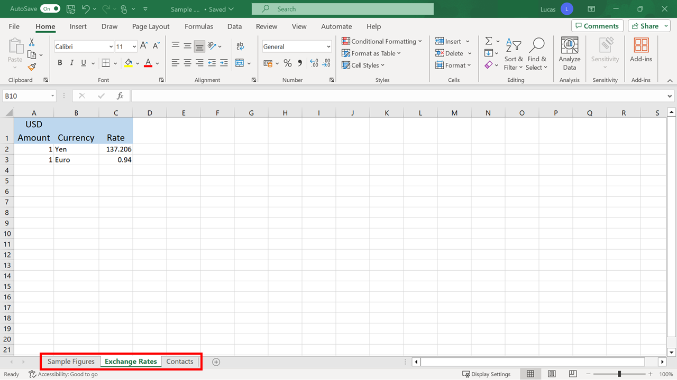

1. Finally, you need to hide the **Contacts** sheet since you don’t need it for the presentation on the company’s latest financial data. Select the sheet. On the **Home** tab in the **Cells** group choose **Format**. Then select **Hide & Unhide** to hide the sheet.

**Tip:** Hiding and unhiding sheets is covered in the reading *Working with worksheets.*

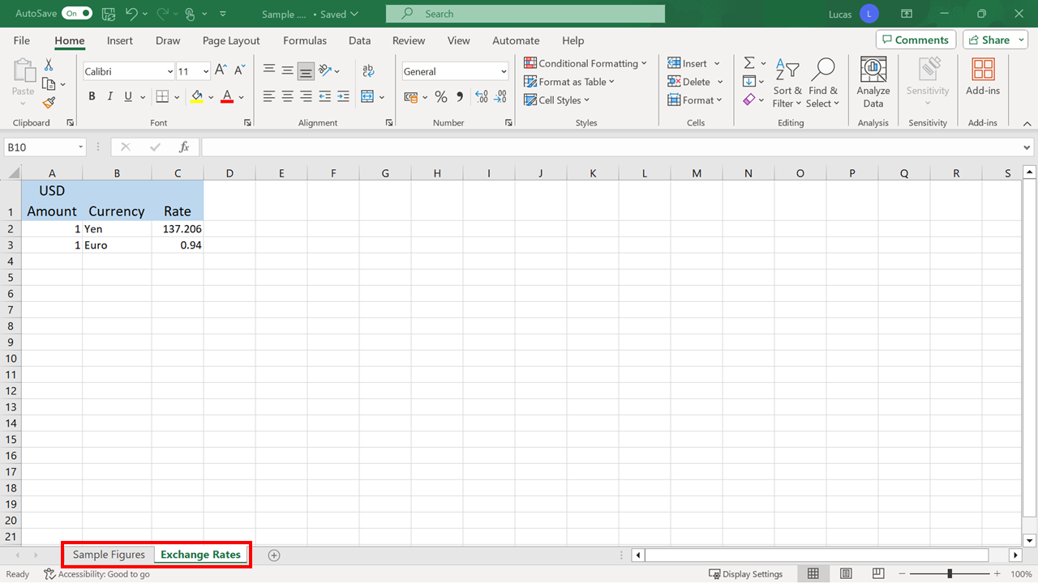Workbook with Contact sheet hidden

**Completed examples**

Compare your work with our finished versions.

**Sample figures sheet**

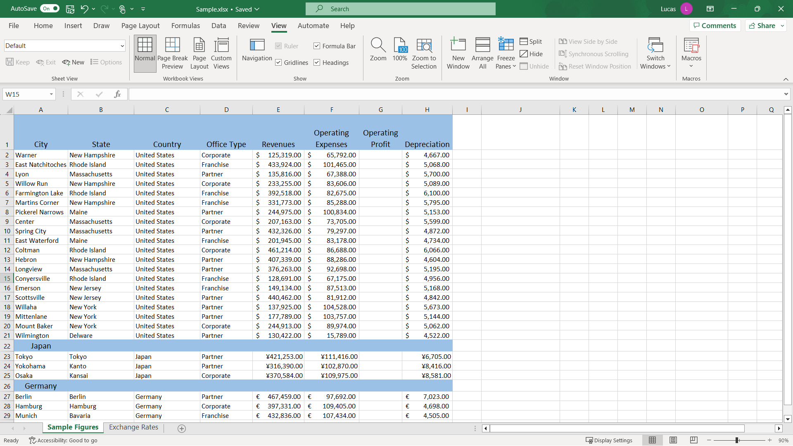

**Exchange rates sheet**

Final version of Exchanges Rates sheet

**Conclusion**

Your aim in the exercise was to prepare the Excel workbook for your Adventure Works financial data presentation. The worksheet is now adjusted for your presentation because you have added the required data and improved its readability. As you worked through these steps, using various techniques to complete this exercise, you gained experience in editing a Microsoft Excel file and formatting it to a professional standard.